PHARMACEUTICAL INDUSTRY
MANAGEMENT CASE STUDIES / FAR-01

Performance evaluation and management targets in four days
  - Canadian pharmaceutical company with operations in Latin America
PRODUCTIVITY | QUALITY | SERVICE | INNOVATION
In four days, the project brought together performance ratings, an individual talent fingerprint and management targets for each person. Night-shift plant employees also participated, including people who could neither read nor write and who defined their own targets.

CONTEXT AND PARTICIPATION
A regional management objective. The intervention was carried out for a Canadian pharmaceutical company with operations in Latin America. Its objective was to bring together performance and talent information in Mexico and align job criteria across Mexico and the company’s other regional operations.
Four dimensions for each person. The evaluation brought together individual ratings for productivity, quality, service and innovation. Its individual scope provided a performance reference in these four dimensions for each participant in the operation being evaluated.
Night-shift plant employees. The work included night-shift plant employees, including people who could neither read nor write. They defined their own productivity, quality, service and innovation targets for their work.

DELIVERABLES AND RESULT
Individual talent fingerprint. In addition to performance ratings, a talent fingerprint was compiled for each person. This deliverable formed part of the individual information brought together during the intervention.
Job responsibilities and management targets. Individual targets were defined for productivity, quality, service and innovation. Job responsibilities and targets were rolled out from Mexico to the company’s Latin American operations.
The achievement in four days. In four days, the project brought together ratings, talent fingerprints and individual management targets. The participation of night-shift plant employees was part of this result.

MANAGEMENT CASE STUDIES / FAR-01

What the project delivered
  - Individual deliverables and regional rollout
FOUR DAYS
Deliverable | Result
Productivity | Individual rating and target definition.
Quality | Individual rating and target definition.
Service | Individual rating and target definition.
Innovation | Individual rating and target definition.
Individual talent fingerprint | An individual record of each person’s talents.
Job responsibilities and targets | Rollout from Mexico to Latin American operations.
Night-shift plant employees | Employees who could neither read nor write also participated and defined their own targets in all four dimensions.
Time frame | Four days to bring together individual ratings, talents and targets.

MANAGEMENT CASE STUDIES / FAR-01

PHARMACEUTICAL INDUSTRY
  - Current commercial network countries and rollout from Mexico
LATIN AMERICA
Country | Map reference
Mexico | Mexico as the origin of responsibilities and targets
El Salvador | Country with current commercial presence
Nicaragua | Country with current commercial presence
Costa Rica | Country with current commercial presence
Panama | Country with current commercial presence
Dominican Republic | Country with current commercial presence
Colombia | Country with current commercial presence
Chile | Country with current commercial presence

From Mexico to Latin America
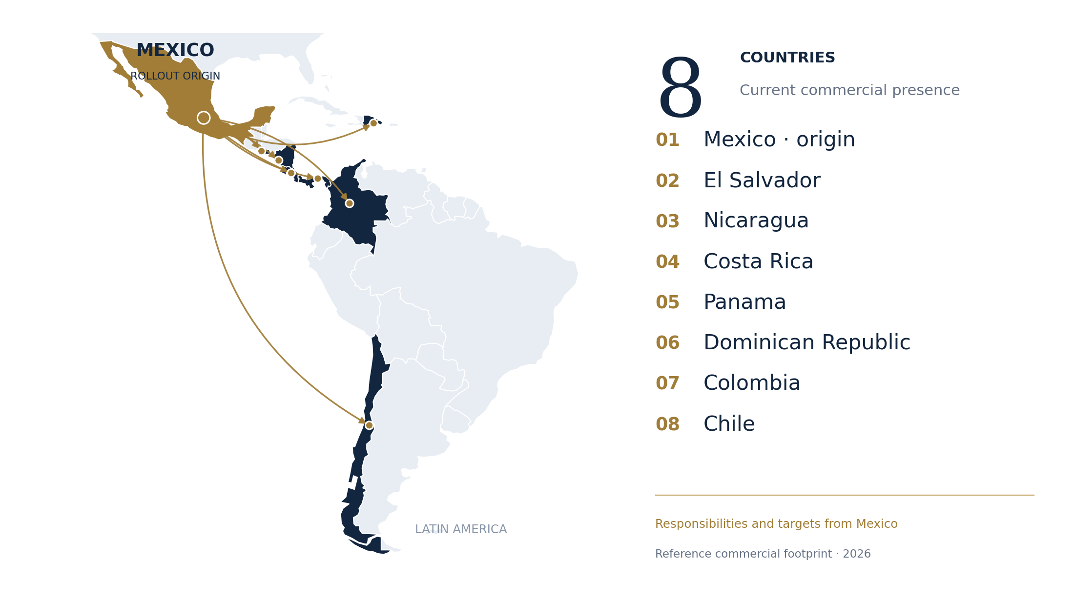
The map uses countries with current commercial presence as a geographic reference. Arrows illustrate the regional rollout of job responsibilities and targets from Mexico described by Sol D’Antin; they do not identify the project’s historical destinations.
Country source: Apotex Health Corp, May 2026 prospectus, printed page 76. Cartographic base: Natural Earth.
View the source for the current commercial footprint

